.
INDIA S NEXT PM IS AN EGYPTIAN BELLY DANCER DUE TO A RAPE BY RAHUL GANDHI, SON OF SHOORPANKA GANDHI

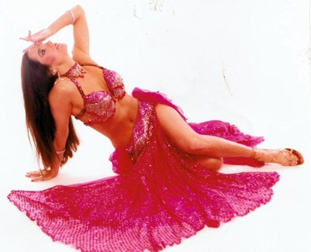

Shoorpanaka Gandhi alias Sonia Gandhi’s link to the Italian spy agencies was reported in the English newspaper ‘The New Indian Express’ dated 17 th April 2004. Those who know the Christians esp. the Kerala Christians, this information was not a shocker. Long back they told the story of blackmailing of Jawaharlal Nehru by the Christian missionaries, for unhindered conversion of North Eastern states of India. This has resulted in the conversion in NE, of Hindus to Christianity at gun point to nearly 100% Christianity as on today from a starting point of 0% Christians at the time of independence. This as per the Kerala Christians is due to the sexual activities of Nehru. Nehru had produced an illegitimate son and he was growing up in one of the Christian orphanage in Bangalore and the missionaries blackmailed Nehru with this information. So there had to be a follow up after Nehru’s death for the unhindered conversion activities of Christian missionaries. That is when one well known Christian Bishop of Kerala went to Rome and consulted OPUS DEI, the Christian spy agency that even murdered some of the Popes. Rest is history and a young uneducated Italian girl was sent to England as a housemaid was identified and a plan was put in place. The girl had no education except a three month training on how to speak English in a coaching class in Cambridge. All such girls used to make some extra money by having some boyfriends and this one had three boyfriends, a German, one Scindia and one Rajiv Gandhi from India. When Rajiv Gandhi shifted from Cambridge to London, after failing in the examinations, the girl was sent to London by OPUS DEI. There this girl by name Antonia Maino, who was the daughter of a Fascist in a Russian jail got a job with a Pakistani ISI operative known as Salman Tassir, who also happened to have and import export business in Dubai. The rest is history and what our Kerala Syrian Christians predicted came true. Seeing this takeover of India by an Italian spy Shoorpanaka Gandhi the Muslims who consider India to be a Mogul land wants to take over India in a similar manner. Muslims always slow in the brain function did a similar thing like the christians did but after some 600 years. Muslims traders produced their own Prophet in the same manner as the christians by copying the method adopted by King Constantine in AD 325 who created a fake Jesus and a fake Christianity by a committee. The muslims went around and produced their own fake prophet in the same pattern and occupied a Hindu temple and threw out all idols except one Siva Lingam to which they pray even today.

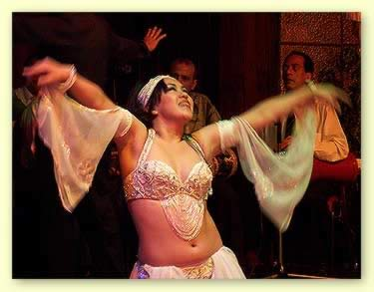

So the muslims have understood that if they have to take control of India, they have to look at the next generation and they decided to use Rahul Gandhi. Salman Khursheed the muslim loyalist of Shoorpanaka Gandhi who protected Rahul after his gang rape incident from the mob and from the obedient Indian press, is the brain behind this plan along with other well known muslims of Pakistan. Even though Rahul married secretly a Columbian drug lord’s daughter, he was forced to live away from his wife because of fear of adverse public opinion. All the muslims wanted to sent sexually dissatisfied Rahul on an Arab tour of good will. What this can result is well known. This could end up in India having the next Prime Minister an Egyptian belly dancer, one of the many Rahul could end up in raping and had to marry all of them compulsorily after adopting Islam only as his religion, from his Muslim Christian parentage. So we go on an entertaining and future conscious journey to select a Belly dancer for Shoorpanaka Gandhi’s wayward son Rahul Gandhi.

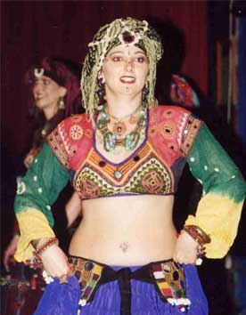
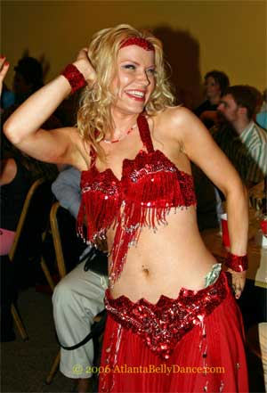

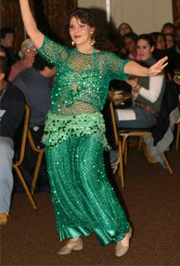

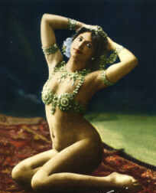

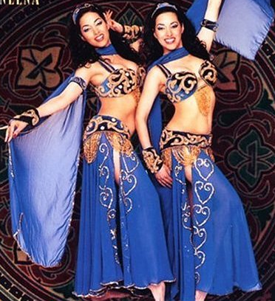

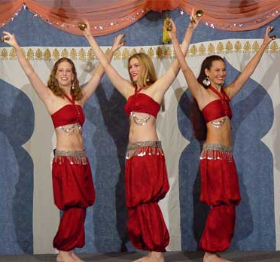

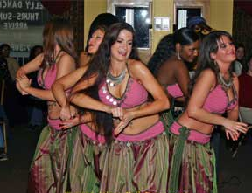

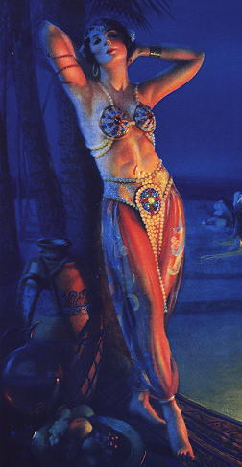

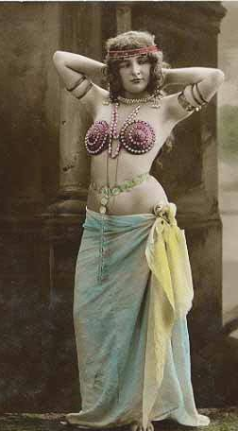

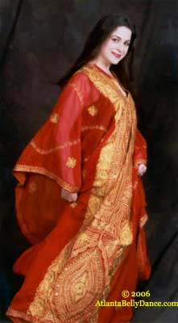

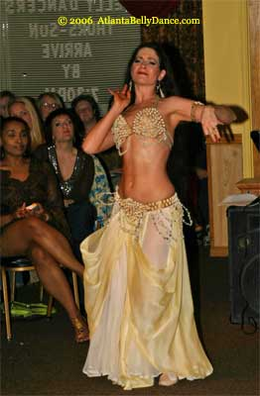



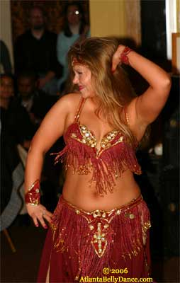

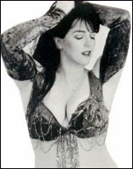

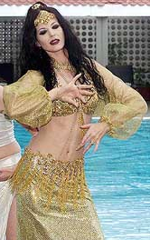

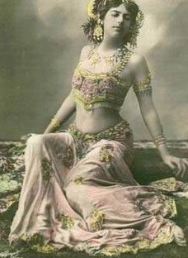

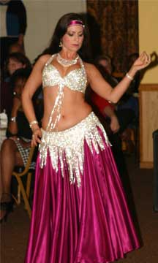

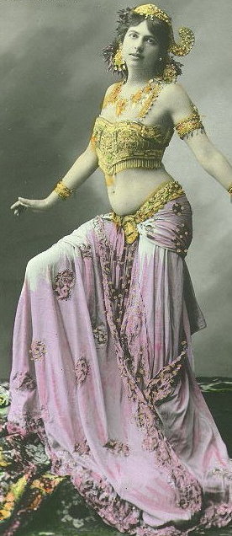
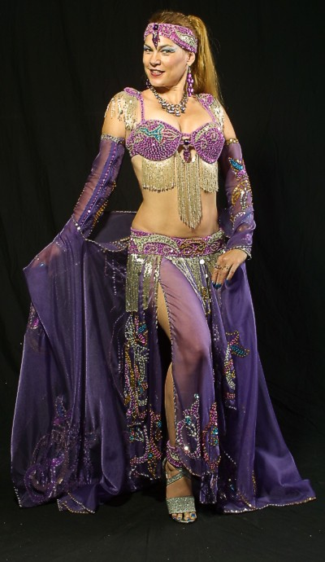

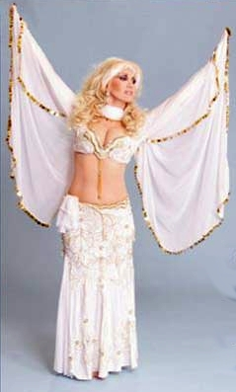



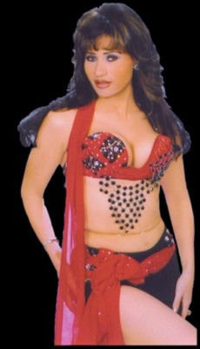

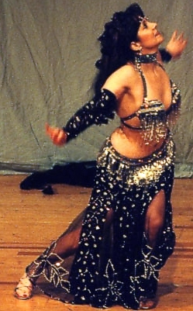

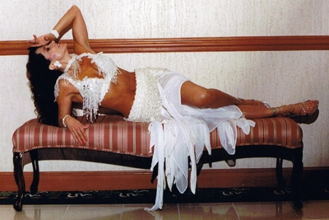

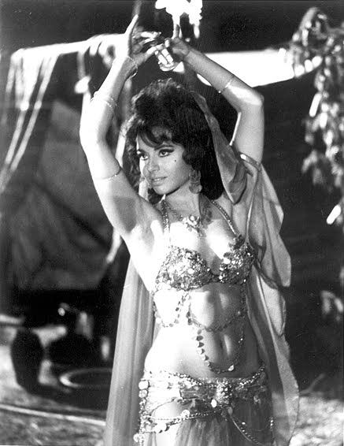

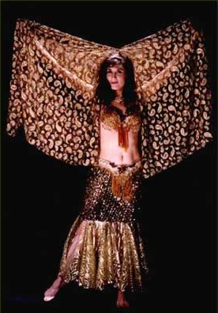

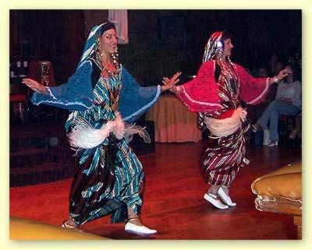

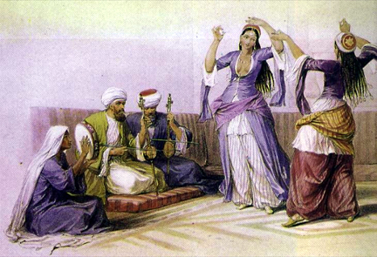

So we start our story with some background information about the Kerala Christians who broke the story of Shoorpanaka Gandhi. Kerala Christians are converts from an untouchable community called Paraya community of Hindus. Parayas used to bury their leaders vertically and after conversion to Christianity they bury the Christian bishops vertically. Rev. Samuel Mateer FLS wrote a book ‘Native Life of Travancore’ in the 19th century after living among the Syrian Christians during his visit, ISBN-10-8120605144. Rev. Samuel Mateer FLS confirms that the Christian converts were indeed the Paraya Christians and if anyone have a doubt, all he has to do is look at A.K. Anthony who is the defense minister of India and definitely he does not look like the descendents of Syrians as is being falsely claimed by the Kerala Christians. Another group of Paraya Christians wanted to be Brahmin converts. They also wanted to be converted by one Saint Thomas who was one of the earliest organizers of Christianity even before a Roman Committee in AD 325 decided to award divinity to a Jesus Christ who was never lived on earth. This group of Paraya christians, created a story that they were converts of Brahmins, by St. Thomas who had arrived in Kerala in 52AD. This fake story needed evidence and to create it the Kerala Paraya christians moved over to Tamil Nadu. Tamils are of low IQ like Muthuvel Karunanidhi and Ramdoss, so the British were able to prove to the Tamils that they are indeed like the black Africans and is a race called Dravidians with very low intelligence. Tamils are so dumb that the Madras University gave a doctorate to a christian priest, for his thesis proving that ‘Tirukkural’ was written by Jesus and it was copied by Tiruvalluvar who wrote Tirukkural some 2200 years ago. Madras University is giving another doctorate to Shoorpanaka Gandhi who had three weeks of English education at Cambridge in a roadside coaching class meant for child prostitutes and barmaids arriving in England from Italy. These Tamils have created the world’s dirtiest slum in Dharavi are are very dirty mentally also. This is so clear if one look at the present union health minister Ramdoss. Tamils are also very dirty physically and it becomes very clear if one looks at Stanly medical college where the students are down with dengue. The Tamils have driven out most of the fair skinned educated classes mainly Brahmins out of Tamil Nadu. The Paraya Christians and the Europeans who have brainwashed the low IQ Tamils in to believing that Tamils are some inferior Dravidians could occupy the temple lands to construct churches. Kerala Paraya christians have the same features of the remaining Tamils and with the support of the newly created Dravidian brains, the Kerala Paraya christians, destroyed temples like Kapaleeswara temple and constructed the Santome church in Chennai without any protest. The Dravidian leader Periyar was a believer who was thrown out of a free food distribution centre in a North Indian temple. He vowed to fight all Hindu temples and created a Dravidian party, denounced all Gods and proclaimed that there is no Hindu Gods in public, and proclaimed that there were no Mohammad or Jesus in private for fear of getting killed by Muslim and Christian terrorists. The Tamils thus became Dravidians and prayed only in the night in private, when the Kerala christians are not around, and denounced all Hindu Gods but praised christian and muslim Gods in public. The Paraya Christians took over the Velar Kanniamman temple and converted it in to Velankanni Mata and spent crores to make it in to a pilgrimage site for the Kerala Paraya Christians. Unfortunately during the last tsunami, the tidal wave entered inside the prayer areas and many have been washed away directly to heaven. The Paraya Christians created the fake St. Thomas visit and established that Thomas walked over the dirty areas of the present St. Thomas mount in Chenai. Paraya Christians imported sand from Kerala, to Thomas mount and started making money by selling it by the kilos, saying that the sand is sacred as the divine fake Thomas, an agent of God walked there. They even killed the St. Thomas in Tamil Nadu filmy style by an emaciated Brahmin, to create a martyr out of the non existent Thomas. It was like the modern murder story hoisted upon Kanchi Seer by the Christian mafia with the help of the idiotic Tamil politicians after paying heavy bribes to the police and the judges. The Thomas story is proved to be a fraud after the present Nazi Pope Joseph Ratzinger, was a Hitler Youth and the head of Opus Dei,and who knew that even Jesus was fake, told that St. Thomas visited the present Pakistan and never went to Kerala or even to South India where Chennai is located.

If one closely look at the Kerala Christians, they all are looking like A.K.Anthony, like the actual tribal they are, with a matching genetic make up. This feature helped the Paraya christians to get back the reservation recently in Tamil Nadu. The Kerala Paraya christian converts were the spies and eyes of the Europeans. This had helped them to get benefit in ways that was never intented. Many of the present day Christians in Kerala have very good European features and white skin because the Europeans were kind enough to sleep with the better looking Paraya christian women, who were brought up on a daily dose of beef. But when the Christian prostitute nurses moved in to Gulf during the oil boom, many of the present day Kerala Paraya Christians were born with Arabs features like the curled hair. The Paraya christians were also the most trusted assistants of the Nehru family and Nehru’s were the descendents of the Babar. The Paraya christians were able to watch the Nehru escapades closely and were able to write books on Nehru family members revealing all their secrets. After this much introduction, we can go back to the main story.

Our story line is that, Rahul Gandhi’s recent gang rape of Sukhanya Devi, was a test conducted on him by the muslim congressmen like Salman Kurshid etc, even though the truth is much simpler. Rahul Gandhi was fully drunk along with his friends and to show that he is a man of action he fed liquor to a Hindu girl who were called to his temporary office in Ameti, and raped her first. But those who organized the clever rape test for Rajiv, never expected the agitation that followed. Hindus are basically very obedient and mild, even if some among them were killed periodically by the christian terrorists in North East or by the muslim terrorists all over India. Hindus are so good in keeping communal harmony even in the face of a lakh being killed on a daily basis, in the initial years of Babar who is the ancestor of Rahul’s grandmother Indira Gandhi. Yet the Hindus agitated on a simple rape. The muslims gang around Shoorpanaka Gandhi had taken prior permission for the rape test from Shoorpanaka Gandhi, saying that Rahul is actually a Hijada in a man’s cloth and this was proved during UP election time. The agitation by Hindus, annoyed Shoorpanaka Gandhi who was happy about the virility of her cross breed son, who was of late showing hijada tendencies, and so ordered that the Hindus should be disciplined. The real aim of the test by the muslim assistants of Shoorpanaka Gandhi, was to check Rahul Gandhi’s ability to rape muslim girls in the future. They hoped that if Rahul can rape some muslim girls in Egypt during his future trip, Rahul will be forced to marry them and in the Rajiv Gandhi way, the Egyptian muslim girls could control the future of India, as is being controlled by a Italian christian prostitute at present. The ability to rape is a requirement for any leadership and this was best tested in Tamil Nadu. Thus the son of Karunanidhi abducted a Tamil muslim girl and rape her and settled the issue with lot of money. Karunanidhi, who is totally a Dravidian idiot, chose the name ‘Stalin’ for his son, thus preventing the safe travel of his son anywhere outside India. Other wise his son would have raped a cheap and fair muslim girl from one of the ex USSR nations. Stalin is going to be the future CM of Tamil Nadu, and Stalin did to prove his manhood. Congress knew the DMK designs for the take over of TN and later India, through the rape method. The muslims surrounding Shoorpanaka decided that before Stalin could take over the whole of India, a muslim takeover India is needed to make India a true land of Islam .

A muslim take over of India can be carried out with out a war if Rahul Gandhi rapes some muslim girls and he will be allowed to marry all those muslim girls whom he can rape. After all Shajahan who converted the Shiva temple to a burial palace with out the dead bodies inside the tombs and is being called Taj Mahal had some 5000 prostitutes. Shajahan had even raped his own daughters and thus proving that he is the romantic king of all times. Shajahan used the rape method like his ancestors to become the romantic ruler of India in the minds even the Hindus. Rahul’s rape will avoid the killing of Hindus as happened centuries back.

Long back the war to take over India by Muslims was started from Iraq on the orders of Hajjaj, the Muslim governor of what is now Iraq. Muslim invaders began entering India in the early 8th century. Starting in 712 the raiders, commanded by Muhammad Qasim, demolished temples, shattered sculptures, plundered palaces, killed vast numbers of men - it took three whole days to slaughter the inhabitants of the city of Debal - and carried off their women and children to slavery and rape. Hajjaj ordered Qasim to kill everyone as per Koran [47.4]: "0 True believers, when you encounter the unbelievers, strike off their heads." Qasim obeyed, and on his arrival at the town of Brahminabad massacred between 6,000 and 16,000 men. So if Salman Kurshid’s plan to hook up Rahul Gandhi with Egyptian girls, esp. the belly dancers, it could be in the best interest of Hindus as it will avoid killing of Hindus. In the face of murder and rape, Hindus had maintained secularism and tolerance with the barbaric muslims as the Hindu men found that they don’t have to do hard work on their womenfolk to produce an off spring, and the muslim were willing to do it at no extra cost. Rape by Christians and muslims on Hindu communities appears to be a great relief for most of the Hindus even in the present time. So Salman Kurshid was sure that the rape plan for Rahul will get full support from the sick humans like Arjun Singh and other leaders.

Media was asked not to mention the Rahul rape in Amethi. The victim of the 3rd December 2006 gang rape led by Rahul Gandhi was Sukanya Devi and she resides at house address 23-12 Medical Choke, Sanjay Gandhi Marg, Amethi, Raebareli, UP, India. Shoorpanaka Gandhi and her coterie were able to terrorize and gag the press in India, but the rape incident got widespread coverage, thanks to the internet. Calling these news reports, as anti-Rahul write-ups by the christian controlled media in India, Shoorpanaka Gandhi issued notices to a post box in USA that first blogged the rape instead of filing an FIR. If FIR is filed and If found guilty of rape, all the rapists including Rahul Gandhi would be punished as per IPC. Instead Shoorpanaka adopted the mafia tactic and sent goondas. The Police refused to book any complaint and advised the victim, not to report it. Sukanya Devi should thank her stars for being born in UP and if she were in Tamil Nadu, the Dravidian policemen would have again raped her in the police station as is regularly occurring in Tamil Nadu. Dravidian policemen would have told her that similar rape is acceptable in Tamil Nadu as the Tamil Nadu Chief Minister M. Karunanidhi’s son Stalin’s once abducted a muslim girl and raped her without any problem and because of that Stalin is sure to be the future Chief Minister of Tamil Nadu.

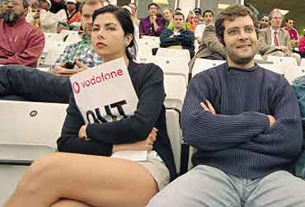
Rahul Gandhi says that he loves this Spanish woman Veronica, daughter of a Spanish couple living in Venezuela whom he secretly married

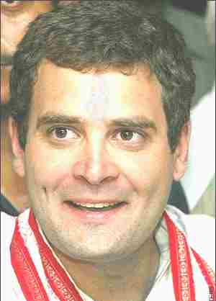
Sukanya Devi and her rapist Rahul Gandhi

A Group of 1000 Congressmen roamed the town on that night and kept warning people to keep their mouth shut otherwise they will kill all of them. On Feb 7th 2007 the Intelligence Bureau goons were sent by Shoorpanaka Gandhi and conducted ‘Operation Bangla’ in Amethi. They have detained 15 people in the Rahul Gandhi rape case. The goons in the Operation Bangla was made up of mostly Congress goons and some Intelligence staffs. A perfect example of Italian Mafiosi Shoorpanka Gandhi’s Intimidation tactics to kill the truth. It looks like India is a BANANA REPUBLIC and the leading media never dared to report the matter.
We should look deeper in to the character of Rahul Gandhi who is the torch bearer of his great grand father Jawaharlal Nehru, who had raped Lady Mountbatten to take vengeance of his imprisonment by the British. AIDs was not an issue at that time, but Nehru got what is available at that time and had to be satisfied with only the syphilis from Lady Mountbatten. Nehru died of complications from the tertiary stage of syphilis. Now the torch bearer Rahul Gandhi uses nirodh all the time to avoid what had happened to Nehru. His legal grand father on mother’s side was a jailbird in Russia, where he died of extreme cold. Rahul Gandhi has no idea who his actual grand father is as his mother Shoorpanaka Gandhi had to change the year of birth from 1944 to 1946 and even changed the place of birth to show that she was born while her father was in Italy and not while her father was in jail in Russia as was reported by the Italian embassy certificate.
Rahul along with his temporary live in Columbian girl friend and now his secret wife, Juanita alias Veronique, on September 2001, was arrested in United States of America’s Logan airport in Boston, by the FBI. Rahul was having an Italian passport and was carrying suitcase full of dollars. It was a case of illegal possession of. US $ 200,000 of drug proceeds. Brajesh Mishra whose daughter Jyotsna is married to an Italian and is living in Italy is a CIA mole in the Prime Ministers Office of Vajpayee, intervened on behalf of Shoorpanaka Gandhi. Rahul Gandhi was released after the Indian Ambassador talked to Bush Administration. A suit has been filed in the High Court in Lucknow about this matter. Brijesh Mishra has strong connections with Shoorpanaka Gandhi's Italian family through his daughter Jyotsna. Shoorpanaka was in total control of the BJP led government through men like Brijesh Misra while the sick Vajpayee was being administered with steroids to keep him awake and walking. When Indian flight IC814 was hijacked, another PMO man in Vajpayee’s office, N.K.Singh’s brother in law was in the flight. So the government did not allow the plane to be stormed while in an Indian airport, and instead sent another Union minister to accompany the terrorists for the safety of Singh’s brother in law. The terrorists slit the throat of one of the Hindus and raped his newly married wife. Hindus in India kept secularism and tolerance in the face of this rape incident. This incident was known to the muslim associates of Shoorpanaka Gandhi, and they expected full cooperation from BJP for the proposed Rahul rape of Egyptian belly dancers and the take over of India to become a true muslim state.

There was no investigation when Shoorpanaka Gandhi lied about her birth date, and birth place or voted even before she became an Indian citizen. Shoorpanaka Gandhi first declared her birth date as 1944 and birth place as Luciana. The birth place was changed and again changed in the declarations to the Election commission. This was no big deal as Shoorpanaka put a criminal called Navin Chawla, who did many nasty things during Emergency, and is now running an NGO for the congress MPs for converting their MP funds to black money.

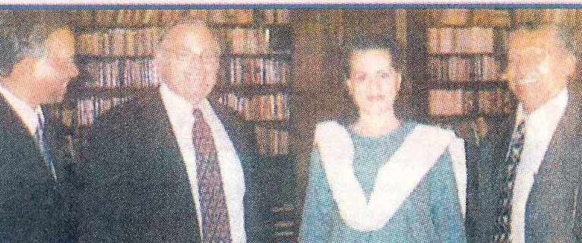

Shoorpanaka Gandhi with the christian conversion terrorist Ron Watts. Watts was deported from India, but still operate in India with the help of the Pope’s Italian spy Shoorpanaka Gandhi. The Italian catholic christian immigrant turned Indian politician, Mrs Antonia Maino Gandhi, alias Sonia Gandhi now known as Shoorpanaka Gandhi after she had informed the Supreme court that there was no Ram. (The Gandhi surname is not related to the India’s founding father Mahatma Gandhi, but a stolen surname to hide the muslim surname Nehru. ) Presently Shoorpanaka Gandhi is carrying out conversion activities using Ron Watts who is being defended in Indian courts by Palaniappan Chidambaram Chettiar’s wife Nalini Chidambaram.

The lies about the birth year and place of birth was confirmed by the Italian embassy which submitted her birth certificate to our Home ministry in 1983. Sonia Gandhi’s name was Antonia Maino as per this certificate. This true birth certificate was submitted by the Italian embassy to the Indian Home Ministry when Antonia Maino applied for Indian citizenship. When Rajiv Gandhi married Antonia Maino newspapers had written that both of them were of the same age. It also confirms that Sonia’s birth year was 1944. . Antonia Maino’s father, who was a mason and a fascist, Signor Stefano Maino, was a prisoner-of-war in Russia from 1942 till Italy surrendered to the Allies in 1945. It is obvious that Maino cannot be the father of Antonia Maino alias Shoorpanaka Gandhi. So the date of birth and place of birth of Antonia Maino alias Shoorpanaka Gandhi had to be changed to cover up this fact that her real father is some one else in Italy Her new date of birth became December 9, 1946, and her place of birth became Orbassano. The place of birth was change again in her affidavits. Instead of investigating all these fraud by Shoorpanaka Gandhi, Brijesh helped Rahul Gandhi and was working for Shoorpanaka Gandhi while heading Prime Minister Vajpayee’s Office. Even after the UPA government came in to power Brijesh was holding a secret official position in the present UPA government that entitles him to a diplomatic passport.

According to the news report in the Indian Express, dated January 3, 2005, Rahul Gandhi had stayed with his Colombian girl friend Juvenita in Kumarakom Taj hotel, near Kochi, Kerala and stayed for a week in the same suite and enjoyed the Kerala style sex with this Colombian girl. One Prof. John M Itty had filed a case against Rahul Gandhi under Immoral Trafficking Act. Rahul Gandhi managed to get admission in the prestigious Saint Stephen College in Delhi, in 1989 from the sports quota in shooting, and the only shooting sport Rahul knows is rape of congress workers. In 1990 he left the college without any degree and joined the Harward Uiversity in the US for a degree in Finance. Rahul met his Colombian girl friend and had regular intercourse, but failed complete the university course.

Schweitzer Illustrierte, a Swiss news magazine, had published in November 1991 issue that the Soviet intelligence agency KGB had deposited US $2 billion in a Swiss bank account in 1985 in the "minor" account of Rahul Gandhi managed by his mother Shoorpanaka Gandhi.. Bofors kickbacks will pale before the KGB payoff to Rahul Gandhi. The then KGB chief Victor Chebrikov had sought, in writing in December 1985, from the Central Committee of the Communist Party of the Soviet Union (CPSU), "authorisation to make payments in US dollars to the family members of Mr Rajiv Gandhi, viz Sonia Gandhi, Rahul Gandhi and Ms Paola Maino, mother of Sonia Gandhi." These payments were authorised by CPSU by a resolution CPSU/CC/No 11228/3 dated 20/12/1985 and the same was also endorsed by the USSR Council of Ministers in Directive No 2633/Rs dated 20/12/1985. These payments had been coming since 1971 as the payments received by Sonia Gandhi's family "have been audited in CPSU/CC resolution No 11187/22 OP dated 10/12/1984. During this period (1986-91) Rahul Gandhi was a student at Harvard University (he failed to complete the course, so no degree). But it is a practice of Intelligence agencies to compromise children of those in high office especially of those countries with a dynastic tradition and nepotism. At Harvard, Rahul was easily accessible, and was vulnerable. Rahul Gandhi was thus the KGB conduit for the Mainos and functioned as their Agent of Influence, and is tantamount to making the Mainos traitors in the eyes of patriotic Indians. Janata Party President Dr Subramanian Swamy, had secured an order from the Delhi High Court to the CBI to investigate these receipt of slush money by Sonia Gandhi and Rahul gandhi.

If the plan by the muslim assistants of Shoorpanaka Gandhi succeeds, an Egyptian Belly dancer could be our next Prime Minister. Rahul Gandhi, who is the son of the Bofors chor the muslim Rajiv Gandhi, will most likely to rape an Egyptian Belly dancer during his next visit to Egypt. Rahul Gandhi will get excited very easily and that was the reason why he raped along with his friends one Hindu girl by name Sukanya Devi on 3 rd December 2006. If anyone goes to Egypt, esp. from Dubai virgin Egyptian belly dancers will be presented to them. It is no wonder then, that most of the well to do smuggler businessmen of Dubai has an Egyptian girl as his third or fourth wife. If it is an official Gulf Government project, the entire period of stay by the Government Official will be at the belly dance club, and all the official work will be left to the expatriate minions who accompany them. If it is a recruitment drive all interviews will be with the belly dancers supplied by the Egyptian muslim candidates and all appointment letters are also given to the very effective belly dancers in the bedrooms. One can say that the pimping Egyptians are a very well praying lot in the Gulf region even if they have no idea about the jobs for which they were recruited. Thus the Islamic Brotherhood members of Egypt are all in Dubai, Abu Dhabi, Doha, Riyadh, Kuwait etc and they carry out their terrorist agenda with total local support while working for the arab governments. It is being said that all members of the Islamic brotherhood are highly educated muslim Engineers and Doctors from Egypt and their hold in the Gulf is very extensive.

Rahul Gandhi if succeeds in raping many Belly dancers, all of them will be given to him as wives. After coming back to India, he will release some of them to entertain Laloo Yadav and the Youth congress leaders, thus ensuring total support for him to become the future PM of India. Rahul will sent one select Belly dancer to South India to Stalin to ensure the full and total support of DMK for his Congress party.

Yet this will be only the beginning. As Quttrochi paid money to LTTE, for the assassination of Rajiv Gandhi, Salman Khurshid and E Ahmad will call on their boss Osama bin Laden for a suicide bomber so that one of the most beautiful belly dancer will become the muslim Gandhi like the present day christian Shoorpanaka Gandhi. Once this elimination of Rahul Gandhi and the takeover of power by his muslim belly dancer occurs, there will be no more war with Pakistan as the whole of India will be renamed as Babarstan. Every Indian citizen will get five times one hour rest period for the five prayers they have to perform. As a token of gratitude for praying five times, all males in India will be circumcised to make their penis sharper and easy to clean. Circumcision was started in BC 2300 and the writers of Quran adopted it along with an old discarded God by other, known as Allah. For hygienic purposes Circumcision was started in the Gulf area where there is no water is available to wash the penis after each intercourse. Of course the devout Kerala muslims who elected one Rashid as the King of Khilafat movement in 1921 after killing the Hindus and some British christians use stones like their real Arab fathers who came to Kerala for trading, to dry up the last drop of urine from the penis. Koran has asked the muslims to dry the penis in this fashion. Unfortunately this has resulted in STD among the muslims in Kerala and they avoid sleeping with ladies and use young boys like Rahman (who was a Hindu boy but a Kerala muslim Haji, after contiuously using him killed his father and converted his whole family to Islam) as decreed by Allah to satisfy their lust.

All the males in India now being called Babarstan, will be allowed to have four wives and they can marry any girl from the age of six as Mohammad did. Thus there will be no opposition from any of the Hindus for the take over of India by an Egyption belly dancer. Many like Dawood Ibrahim and Sonia who own Jet Airways and other airlines will import Belly dancers to entertain the passengers inside the aircraft. All police stations and jails will be closed down and Sharia will become the simple rule for cutting the hand for theft, cutting off the head for dropping Koran on the floor etc. All the butchers will have to report to local mosque in the morning, for these cutting operation of criminals. All the women folks will have to wear the veil and will be treated as a huge vagina as specified in Koran. There will be no more IITs or IIMs or interest giving banks. Life will become one good old sexual orgy for all Indians. All text books will be replaced by a single book Quran that gives all answers for the Human race. All property will become the property of the Wakf board. The only opposition will be from the ‘Jesus calling’ groups in Chennai, but he will be supplied with 10 Egyptian belly dancers and an electronically controlled knee for his walking.

There will be an interim period before the Islamic Paradise can happen. That is when Rahul actually become the PM of India. His mother Shoorpanaka Gandhi will take over the full control of India. She will sent the gun totting NE christian terrorists all over India to convert all Hindus to Christianity. As happened with Rajiv Gandhi, Rahul Gandhi will be dispatched to heaven by a suicide bomber, thus paving the way for the takeover of India by one of the leading belly dancer Rahul Gandhi had raped and married.

Indian army will be sent all over the world to conquer the world and thus India will become the only superpower in the world. Of course all these Islamic paradise can happen only if Rahul Gandhi rapes an Egyptian Belly dancer. The question in front of every one is WILL HE OR WILL HE NOT.

